

**DR.** [**Ala Abuthawabeh**](https://www.youtube.com/@AlaAbuthawabeh)

**Tareq alazzeh**

Assignment #1

Q1

def convert_indian_to_arabic(indian_number):

numeral_map = {

'٠': '0',

'١': '1',

'٢': '2',

'٣': '3',

'٤': '4',

'٥': '5',

'٦': '6',

'٧': '7',

'٨': '8',

'٩': '9'

}

translation_table = str.maketrans(numeral_map)

return indian_number.translate(translation_table)

print(convert_indian_to_arabic('٣ ٢'))

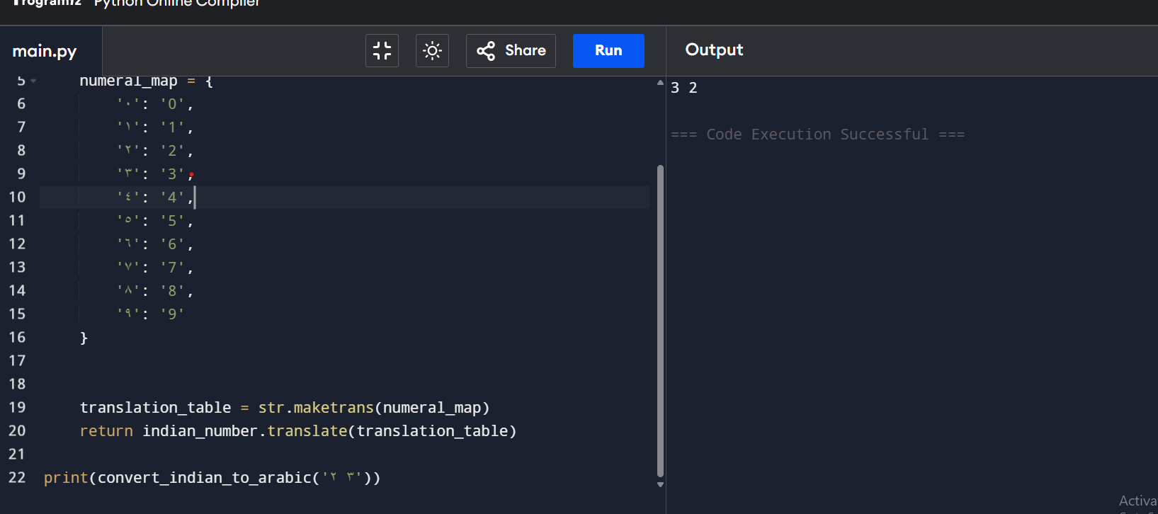

Q 2

import numpy as np

import random

def calculate_standard_deviation(N):

numbers = [random.randint(1, 10) for _ in range(N)]

np_numbers = np.array(numbers)

count = len(numbers)

total_sum = sum(numbers)

minimum = min(numbers)

maximum = max(numbers)

range_value = maximum - minimum

median = np.median(np_numbers)

unique_values, counts = np.unique(np_numbers, return_counts=True)

mode = unique_values[np.argmax(counts)]

mean = total_sum / count

variance = np.sum((np_numbers - mean) ** 2) / count

std_dev = np.sqrt(variance)

return (

numbers,

count,

total_sum,

minimum,

maximum,

range_value,

median,

mode,

mean,

variance,

std_dev

)

def display_results(N):

results = calculate_standard_deviation(N)

numbers, count, total_sum, minimum, maximum, range_value, median, mode, mean, variance, std_dev = results

print(f"Numbers: {numbers}")

print(f"Count (N): {count}")

print(f"Sum: {total_sum}")

print(f"Min: {minimum}")

print(f"Max: {maximum}")

print(f"Range: {range_value}")

print(f"Median: {median}")

print(f"Mode: {mode}")

print(f"Mean: {mean:.3f}")

print(f"Variance: {variance:.3f}")

print(f"Standard Deviation: {std_dev:.3f}")

display_results(6)

